**Social Network Analysis**

**By**

**Patel Akash: - 15BIT029**



**DEPARTMENT OF INFORMATION TECHNOLOGY**

**Ahmedabad 382481**

**Social Network Analysis**

**Seminar**

Submitted in fulfillment of the requirements

For the degree, of

**Bachelor of Technology in Information Technology**

By

**Patel Akash: - 15BIT029**

Guided By

**PROFESSOR TEJAL UPADHYAY**

**DEPARTMENT OF INFORMATION TECHNOLOGY**



**DEPARTMENT OF INFORMATION TECHNOLOGY**

**Ahmedabad 382481**

CERTIFICATE

This is to certify that the Seminar entitled “SOCIAL NETWORK ANALYSIS” submitted by Patel Akash- 15BIT029, towards the partial fulfillment of the requirements for the degree of Bachelor of Technology inInformation Technology of Nirma University is the record of work carried out by him/her under my supervision and guidance. In my opinion, the submitted work has reached a level required for being accepted for examination.

Prof. Tejal Upadhyay Dr. Madhuri Bhavsar

Assistant Professor Dept. of Information Technology,

Department of Information Technology, Institute of Technology,

Institute of Technology, Nirma University,

Nirma University, Ahmedabad

Ahmedabad

**ACKNOWLEDGEMENT**

Thanks to PROF. TEJAL UPADHYAY for his devoted guidance, the work she has done and guiding us through our topic and providing us with all necessary help at every point. We would like to Thanks “Dr. ALKA MAHAJAN, Director of Institute of Technology” and “Dr. MADHURI BHAVSAR, Head of department of Information technology” for inspiring us with their work. We would like to Thanks “Department of Information Technology” for providing us with necessary and latest technology that help us in completing our work.

**ABSTRACT**

The aim of the project to give overview of Social network and its analysis techniques. There are various method, descriptive measures, models that are used to analysis social network and its data. The scope of this project is to find out the easiest way to analyze the Social Network with the help of latest technology. As social data that is obtain are structured, unstructured and semi structured due to which use of Data Mining is important. This project also discussed about Business Intelligence with social network analysis. How Business is carried out with the help of social Network. Various Connection to analysis Social Network has been discuss under this project such as Homophily, propinquity, and Triadic Closure. Various application has also been discussed such as SNA is used in computer supported collaborative learning, Data Mining, Location based interaction analysis, Business Intelligence and Community based problem solving.

**CONTENTS**

Certificate III

Acknowledgement IV

Abstract V

List of figures

FIG 1.1.1 GRAPH OF SOCIAL NETWORK 3

FIG 1.4.1 SOCIOCENTRI 4

FIG 1.4.2 EGOCENTRIC 5

FIG 2.2.2.1 USE OF SOCIAL NETWORK IN BUSINESS 7

**Chapter 1 Introduction 3**

1.1 WHAT IS SOCIAL NETWORK ANALYSIS? 3

1.2 SOCIOGRAM 4

1.3 SOCIAL NETWORK ANALYSIS 4

1.4 TYPES OF SOCIAL NETWORK ANALYSIS 4

**Chapter 2 Literature survey 6**

* 1. EXISTING SYSTEM 6
  2. PROPOSED SYSTEM 6
     1. NEED FOR NEW SYSTEM 6
     2. ADVANTAGES 6

**Chapter 3 Types of Connection 8**

3.1 HOMOPHILY

3.1.1 TYPES OF HOMOPHILY 8

3.1.2 CAUSES OF HOMOPHILY 8

3.2 TRIADIC CLOSURE 8

3.3 PROPINQUITY 9

3.3.1 EFFECT OF PROPINQUITY 9

**Chapter 4 Practical Application 10**

4.1 COMPUTER SUPPORTED COLLABORATIVE LEARNING 10

4.2 FACEBOOK AI 10

4.3 BUSINESS INTELLIGENCE 11

4.3.1 NEED OF BUSINESS INTELLIGENCE 11

4.4 DATA MINING 11

4.4.1 NEED OF DATA MINING 11

**Chapter 5 Conclusion 12**

5.1 REFERENCES 12

**CHAPTER 1**

**INTRODUCTION**

* 1. WHAT IS SOCIAL NETWORK ANALYSIS?
* Social network analysis(SNA) is the process of investigate social structure through the use of network and graph theories.
* It characterizes the network structure in terms of nodes and ties.
* Examples: - Social Media Network, Friendship Network, collaboration graph etc.

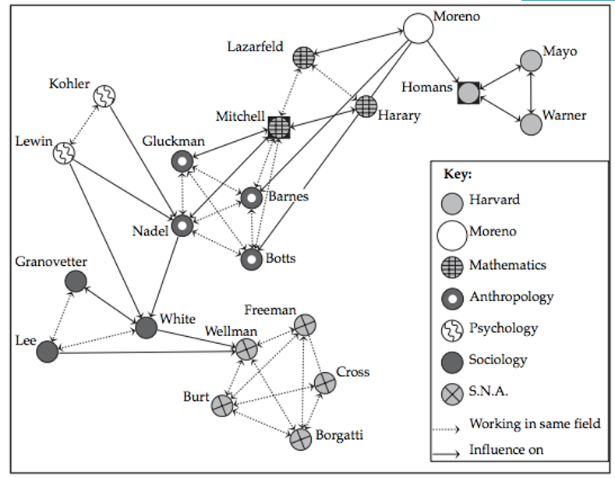

**\***FIG 1.1.1 GRAPH OF SOCIAL NETWORK

**1.2 SOCIOGRAM**

* It is a graphical representation of social relation that a person has.
* The network of SNA can also view through SOCIOGRAM in which nodes are represent as point and ties are represented as lines.
* SNA has emerged as a key technique in modern sociology.

**1.3 SOCIAL NETWORK ANALYSIS**

* It’s the mapping and measuring of relationships and flows between people, groups, organizations, computers, URLs, and other connected entities.
* The nodes in the network are the people and groups while the links show relationships or flows between the nodes.
* It provides both a mathematical and a visual analysis of human relationships.
* It is Organizational Network Analysis for business point of view.

**1.4 TYPES OF SOCIAL NETWORK ANALYSIS**

* SOCIOCENTRIC is a whole network. It creates one network. If your research question is about different patterns of interaction within defined groups.

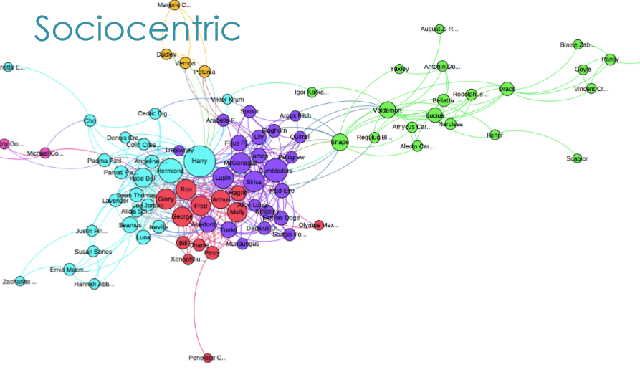

**\***FIG 1.4.1 SOCIOCENTRIC

* EGOCENTRIC is a personal network. It creates many standalone networks. If your research question is about phenomena of or affecting individual entities across different settings.

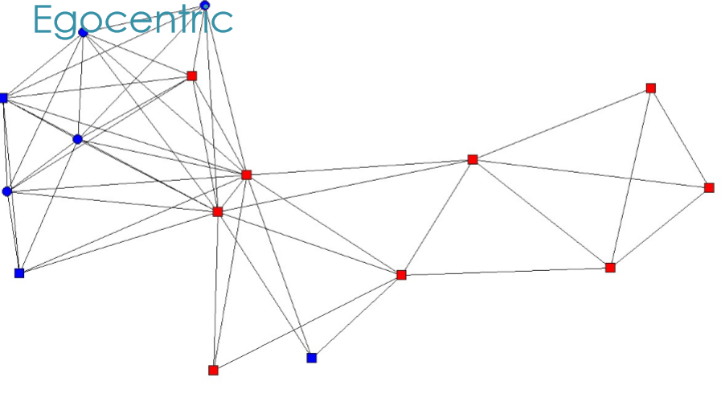

**\***FIG 1.4.2 EGOCENTRIC

**CHAPTER 2**

**LITERATURE SURVEY**

**2.1 EXISTING SYSTEM**

* Existing system is not there.
* It is not efficient.
* People have no contact who are far away from there.
* Communication is poor.
* Relation and bond cannot be predicted.

**2.2 PROPOSED SYSTEM**

The main aim of this project is deep learning of SNA and overcome the present challenges of SNA. Practical application is major part of this project. Effective way of communication, what people search on internet their behavior, how they interact with other people, the analysis of bond formation between members are all covered under Social Network Analysis. The objective is that how customer can be serve through the medium of Social network.

**2.2.1 NEED FOR NEW SYSTEM**

* Now the proposed system is very important as it has many application.
* It predicts according to behaviour of people and provide services and make life easy.
* It is very efficient.
* Relation and reputation can be handled.
* Communication is very strong.
* Strong bond between members can be formed.
* Major use in business.

**2.2.2 ADVANTAGES**

* In Business (Chain network through the medium of Social Network)
* Marketing
* Crime Detection
* Detection of epidemics
* Relationships and reputation
* Benchmarking.
* Micro analysis
* Macro analysis

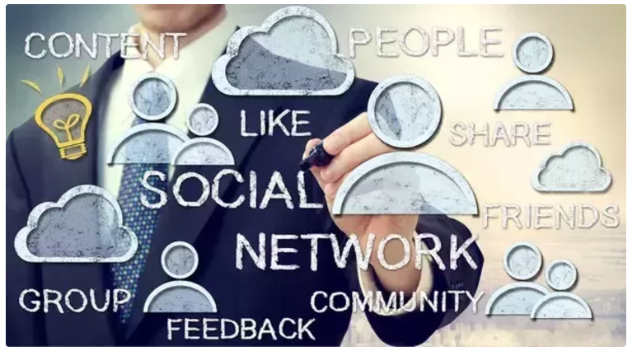

**\***FIG 2.2.2.1 USE OF SOCIAL NETWORK IN BUSINESS

**CHAPTER 3**

**TYPES OF CONNECTION**

**3.1 HOMOPHILY**

* Homophily is the tendency of individuals to associate and bond with similar others.
* More than 100 studies that have observed homophily
* Homophily include age, gender, class, and organizational role.
* Individuals in homophylic relationships share common characteristics that make communication and relationship formation easier.

**3.3.1 TYPES OF HOMOPHILY**

* Status Homophily: It refers to similar social status characteristic. Race, ethnicity, sex, age & acquired characteristic like religion, education etc. are include in Status Homophily
* Value Homophily: It is associate with one who think in similar way, regardless of difference in status.

**3.3.2 CAUSES OF HOMOPHILY**

* Geography: Basic source of homophily is space. People generally are more likely to have close relation with those who are closer in geographic location than those who are far away from them.
* Family Ties: The bond between family members is very strong and it also slow decay. Here distance doesn’t matter also geographic relation does not take any part as if even members are far away kin ties among them produce relatively close relation.
* Isomorphic Sources: Here connection between people form who share three common domain Workplace, Family & informal Network.
* Cognitive Process: People who have demographic similarity tends to share own knowledge and therefore they have stronger communication and they share culture taste which generate homophily.

**3.2 TRIADIC CLOSURE**

* It is the property among three nodes A, B, and C, such that if a strong relation exists between A and B and A and C, there is a weak or strong relation between B and C.
* It can be analysed through Graph.
* It can be measure through clustering coefficient and transitivity of a graph.
* It has a Transitive property
* A trust B, B trust C then A has a basis to trust C.
* Network which do not follow this principle are terms to be poorly connected.

**3.3 PROPINQUITY**

* Refers to physical or psychological proximity between people.
* The tendency for actors to have more ties with geographically close others.
* According to Definition:
  + - High value: Two people living on Same floor or same political beliefs.
    - Low value: people living on different floor or different political beliefs.

**3.3.1 EFFECT OF PROPINQUITY**

* Propinquity is the tendency to form romantic relationship, friendship relationship and many more with those whom they meet often and forming a bond between them.
* Occupational propinquity, based on a person's career, is also commonly seen as a factor in marriage selection.
* Very close relation is form in propinquity.

**CHAPTER 4**

**PRACTICAL APPLICATION**

SNA has a number of application out of which few has been discussed here

* Data Mining
* Location based interaction analysis
* Business Intelligence
* Community based problem solving
* Computer supported collaborative learning.

**4.1 COMPUTER SUPPORTED COLLABORATIVE LEARNING**

* CSCL is a practice of education where learning take place via social interaction using computer and through the internet.
* CSCL includes instructional technologies, education psychology, sociology, cognitive psychology, and social psychology.
* Its help to understand how learners collaborate in terms of amount, frequency, and length, as well as the quality, topic, and strategies of communication.
* It uses graphical representations, written representations, and data representations.
* The focus of the analysis is on the "connections" made among the participants – how they interact and communicate.
* SNA allow the study of pattern within network range and can help to illustrate the extent of participant’s interaction with other members of group.
* CSCL includesMooc course, Distance learning, Online discussion portal which includes Group Work, avoid duplication work, quick, clarification in term of doubt, update of progress.

**4.2 FACEBOOK AI**

* Suicide happens every 40 second in worldwide.
* AI include self-harm prevention features. It detects comments that are likely to include thought of suicide. Then it is checked by company’s community operation team, opening up a new way for trouble user to get help.
* Using pattern reorganization, it will check post & then if needed, make “suicide” or “self-injury” report.
* They have successfully integrated suicide prevention tool in Facebook live.

**4.3 BUSINESS INTELLIGENCE**

* It is set of processes, application, data, technologies etc. which are used for data analysis, presentation and dissemination of business data.
* BI provides historic, current and future prediction of business data.
* It includes following function such as report, data mining, analytics, prediction, process mining, business performance management etc.
* The main aim of BI is to easy interpretation of very big data.
* SNA with Business Intelligence allows to reach a huge number of customers/users at a time resulting into variety of data with hidden knowledge.
* Advertising, marketing, cost saving can be achieved.
* SNA and business Intelligence are inseparable.

**4.3.1 NEED OF BUSINESS INTELLIGENCE**

* The Information and Communication Technologies revolution provided us with large amount of information.
* It is becoming more challenging to handle huge volume of data coming from various sectors.
* This is where BI comes in.
* BI compiles, parses, interprets data into useful reports, patterns to be used by business people.

**4.4 DATA MINING**

* Data Mining is defined as the process of analysing large databases, usually data warehouses, to discover new information, hidden patterns and behaviours.
* DM main application BI and risk management.
* DM directly affect decision making.

**4.4.1 NEED OF DATA MINING**

* The growing nature and use of current social networks are generating highly dynamic data with increasing volume which is structured, Semi structured or unstructured data.
* Moreover, the data is not directly translatable into network-based data that would be useful.
* This is where the ability to perform effective data mining becomes important.
* Mining information from raw data is an extremely vital and tedious process due to dynamic nature of social networks.

**CHAPTER 5**

**CONCLUSION**

The seminar topic “SOCIAL NETWORK ANALYSIS” is very important at many points. SNA is vast uses in many field such as crime detection, marketing, business intelligence, relation, reputation, micro and macro analysis, bench marking etc. SNA and BI are most important and power BI tool is very important for interpreting vast data in understandable form. Previously work is done on static database. Most of data available from SNA is dynamic in nature so new algorithms and technologies are required to handle this vast data. So DM is most important. This paper focuses on mainly on practical application of SNA. This paper gives an overview of key problems and techniques in social network analysis from the perspective of business applications.

* 1. **REFERENCES**

1. Social network analysis Book by John Scott
2. Social Network Analysis It Methods and Applications Book by Katherine Faust and Stanley Wasserman

**Appendix – A List of Useful Websites**

<https://www.wikipedia.com>

<http://www.bbc.com/news/technology-39126027>

https://en.wikipedia.org/wiki/Business_intelligence

https://en.wikipedia.org/wiki/Data_mining